DADS6700 — Data Management for Analytics

Milestone 2 – Relational Database Implementation in MySQL and Analytical Application of the Talent Acquisition Management System

1. Introduction
This milestone demonstrates the physical implementation of the Recruitment Process Management System in MySQL and the development of a Python-based analytical application. The goal is to verify that the relational schema is functioning correctly, can be populated with data, queried efficiently, and consumed programmatically using Python for analytical purposes.
The milestone includes: - Creation of the MySQL database and tables - Population of tables with sample data - Execution of SQL queries (simple → advanced) - A Python Jupyter Notebook connecting to MySQL - Data retrieval into pandas DataFrames - Generation of analytical visualizations (bar chart, histogram, pie chart)

2. Step 1 – Database Creation in MySQL

2.1 Create Database
CREATE DATABASE recruitment_system;
USE recruitment_system;
Screenshot for the schema creation is as follows:
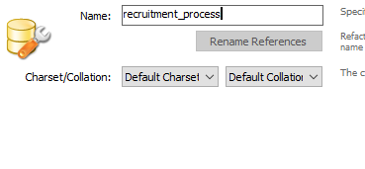
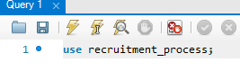

2.2 Create Tables (DDL Script)
The SQL Script to create the tables in our database can be found here.
Screenshot for some of the tables(from our database) creation is below:
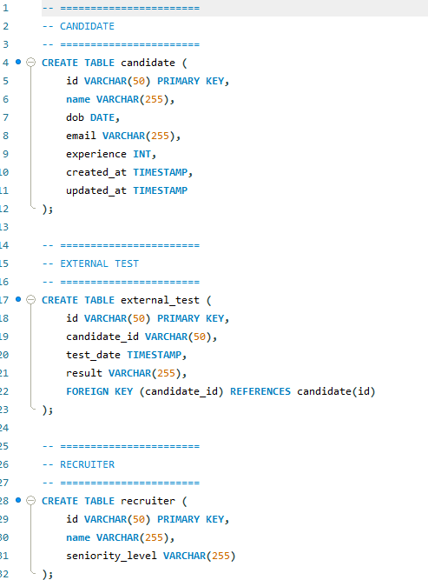

3. Step 2 – Populate Tables with Sample Data

3.1 Insert Data Script
The SQL Script to insert records into our tables in our database can be found here.
Screenshot of insert statements of some of the tables(from our database) is below:
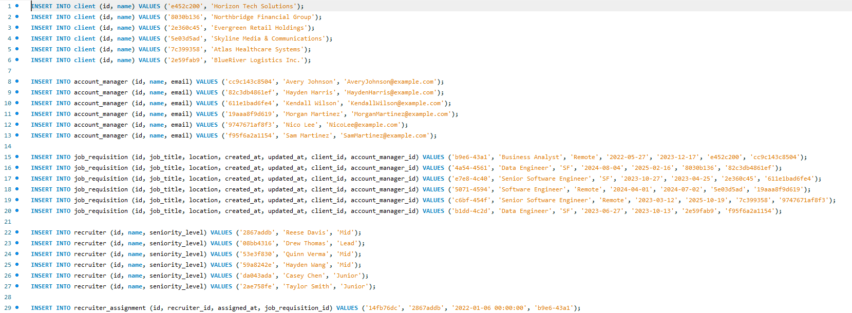

4. Step 3 – SQL Queries (5–8 Required, 12 Provided)
Below are the queries executed on the database. Each includes a brief description and space for screenshots.

Query 1 – Join + Aggregate
SELECT jr.job_title AS Job_Title, COUNT(DISTINCT i.candidate_id) AS Candidate_Count
FROM job_requisition jr
JOIN interview i
ON jr.id = i.job_requisition_id
WHERE i.status = 'Completed'
GROUP BY jr.job_title;
Purpose: Counts candidates who completed interviews for each job.
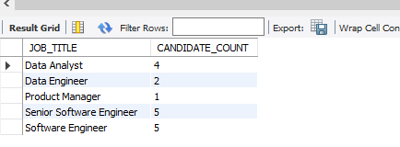

Query 2 – Nested Query
SELECT c.name, MAX(e.score) AS max_score
FROM candidate c
JOIN evaluation e ON c.id = e.candidate_id
GROUP BY c.id, c.name
HAVING MAX(e.score) > (
SELECT AVG(score) FROM evaluation
);
Purpose: Candidates whose maximum score is greater than the global average.
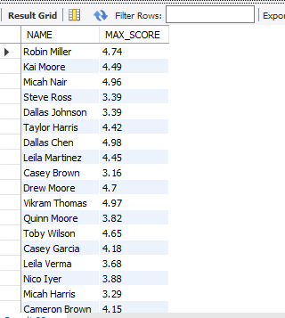

Query 3 – Correlated Subquery
SELECT c.name, i.updated_at
FROM candidate c
JOIN interview i ON c.id = i.candidate_id
WHERE i.status = 'Rescheduled'
AND i.updated_at = (
SELECT MAX(i2.updated_at)
FROM interview i2
WHERE i2.candidate_id = c.id
);
Purpose: Identifies candidates whose latest interview was rescheduled.
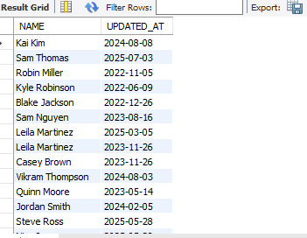

Query 4 – CASE WHEN + JOIN
SELECT
jr.id AS job_requisition_id,
jr.job_title AS job_requisition_title,
CASE
WHEN ob.id IS NOT NULL THEN 'Onboarding'
WHEN ofr.id IS NOT NULL THEN 'Offer Stage'
WHEN iv.id IS NOT NULL THEN 'In Interview'
ELSE 'Sourcing'
END AS pipeline_stage
FROM job_requisition jr
LEFT JOIN interview iv ON jr.id = iv.job_requisition_id
LEFT JOIN offer ofr ON jr.id = ofr.job_requisition_id
LEFT JOIN onboarding ob ON ofr.id = ob.offer_id
GROUP BY jr.id, jr.job_title, ob.id, ofr.id, iv.id;
Purpose: Determines job requisition pipeline stage.
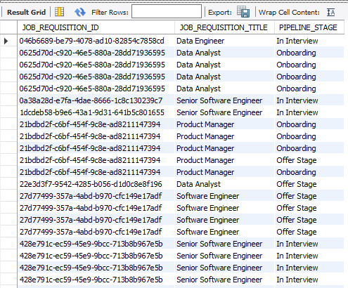

Query 5 – >= ALL
SELECT c.name, e.score
FROM candidate c
JOIN evaluation e ON c.id = e.candidate_id
WHERE e.score >= ALL (
SELECT score FROM evaluation
);
Purpose: Finds top scoring candidates.


Query 6 – > ANY
SELECT c.name, e.score
FROM candidate c
JOIN evaluation e ON c.id = e.candidate_id
WHERE e.score > ANY (
SELECT score
FROM evaluation
WHERE evaluated_at >= CURRENT_DATE - INTERVAL 7 DAY
);
Purpose: Candidates scoring better than any candidate evaluated last week.
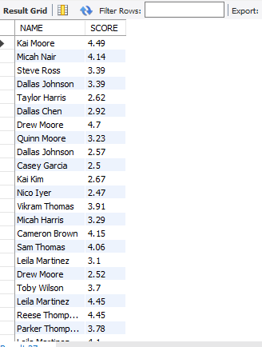

Query 7 – EXISTS
SELECT pm.name
FROM panel_member pm
WHERE EXISTS (
SELECT 1
FROM interview_panel ip
WHERE ip.panel_member_id = pm.id
GROUP BY ip.panel_member_id
HAVING COUNT(DISTINCT ip.interview_id) > 3
);
Purpose: Panel members who evaluated more than 3 candidates.
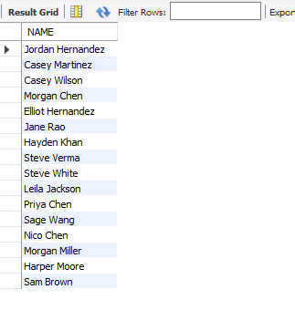

Query 8 – View Creation
CREATE VIEW candidate_interview_view AS
SELECT
c.name AS candidate_name,
i.updated_at,
i.status
FROM candidate c
LEFT JOIN interview i ON c.id = i.candidate_id;
SELECT * FROM candidate_interview_view;
Purpose: Helpful combined view of candidate interviews.


Query 9 – CTE
WITH avg_score_per_recruiter AS (
SELECT
sa.recruiter_id,
r.name AS recruiter_name,
AVG(e.score) AS avg_score
FROM sourcing_activity sa
JOIN evaluation e ON sa.candidate_id = e.candidate_id
JOIN recruiter r ON sa.recruiter_id = r.id
GROUP BY sa.recruiter_id, r.name
)
SELECT recruiter_id, recruiter_name, avg_score
FROM avg_score_per_recruiter
WHERE avg_score > 3.4;
Purpose: Average recruiter score analysis.
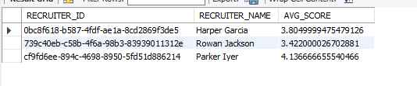

Query 10 – MySQL EXCEPT Alternative
SELECT candidate_id
FROM sourcing_activity
WHERE candidate_id NOT IN (SELECT candidate_id FROM interview);
Purpose: Sourced but never interviewed.
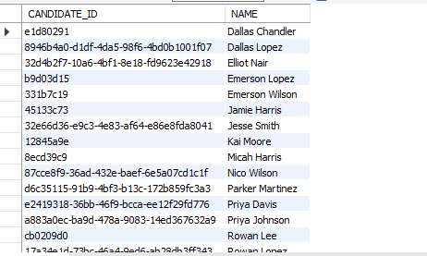

Query 11 – MySQL INTERSECT Alternative
SELECT DISTINCT et.candidate_id
FROM external_test et
INNER JOIN interview i
ON et.candidate_id = i.candidate_id;
Purpose: Candidates who did tests and were interviewed.
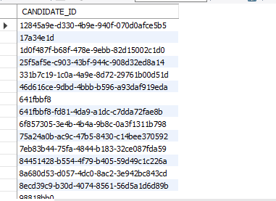

Query 12 – UNION
SELECT job_requisition_id FROM interview
UNION
SELECT job_requisition_id FROM offer;
Purpose: Jobs with either interviews or offers.
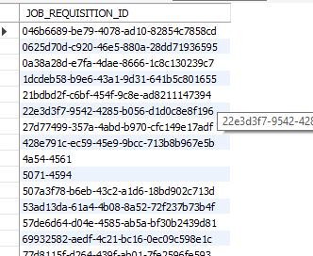

5. Step 4 – Python Jupyter Notebook Application
Below is the application structure and sample code. The actual notebook file can be found here.

5.1 Connecting to MySQL
import mysql.connector
import pandas as pd
import matplotlib.pyplot as plt
import seaborn as sns
import pymysql
# Step 2: Establish a connection to the MySQL database
db_connection = pymysql.connect(
host="127.0.0.1",
port=3306,
user="root",
password="admin",
database="recruitment_process"
)

5.2 Running Queries from Python
# Step 3: Run SQL query #1 to get the number of completed interviews per job title
query1 = """
SELECT jr.job_title AS Job_Title, COUNT(DISTINCT i.candidate_id) AS Completed_Interview
FROM job_requisition jr
JOIN interview i ON jr.id = i.job_requisition_id
WHERE i.status = 'Completed'
GROUP BY jr.job_title;
"""
df_completed_interviews = pd.read_sql(query1, con=db_connection)
df_completed_interviews.head()
Output Screenshot:
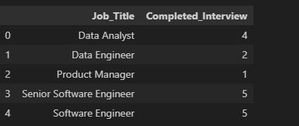

5.3 Plot1: Plotting the number of interviews completed per Job title
# Step 5: Plotting the results of Query 1 BAR CHART
sns.set_style("whitegrid")

plt.figure(figsize=(10, 6))
sns.barplot(
data=df_completed_interviews,
x="Job_Title",
y="Completed_Interview",
palette="viridis",
)
plt.xticks(rotation=45)
plt.title("Number of Completed Interviews per Job Title")
plt.xlabel("Job Title")
plt.ylabel("Completed Interviews")
plt.show()

The rendered plot is: 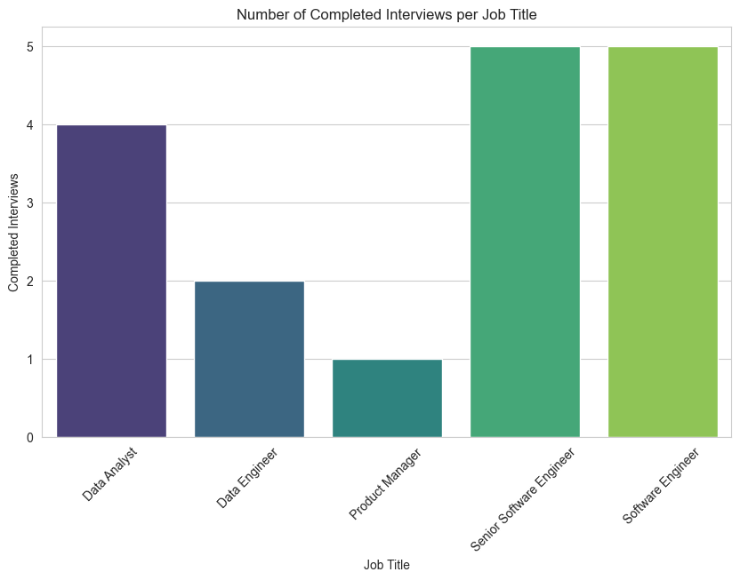

5.4
# Step 6: Run SQL query #2 to get the current pipeline stage for each job requisition

query2 = """
SELECT
jr.id AS job_requisition_id,
jr.job_title AS job_requisition_title,
CASE
WHEN ob.id IS NOT NULL THEN 'Onboarding'
WHEN ofr.id IS NOT NULL THEN 'Offer Stage'
WHEN iv.id IS NOT NULL THEN 'In Interview'
ELSE 'Sourcing'
END AS pipeline_stage
FROM job_requisition jr
LEFT JOIN interview iv
ON jr.id = iv.job_requisition_id
LEFT JOIN offer ofr
ON jr.id = ofr.job_requisition_id
LEFT JOIN onboarding ob
ON ofr.id = ob.offer_id
GROUP BY jr.id, jr.job_title, ob.id, ofr.id, iv.id;
"""
df=pd.read_sql(query2, con=db_connection)
df.head(3)

The output screen for the query is:

The plot rendered is:
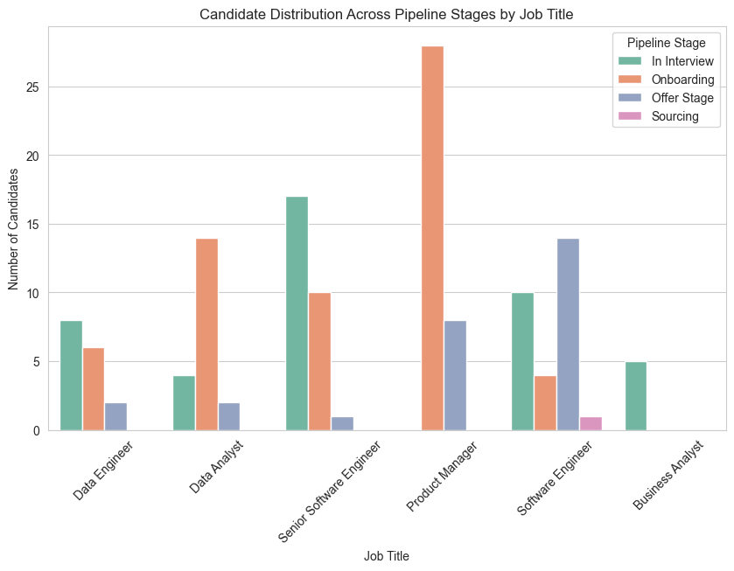

5.5 Plot 3: Bar chart -Candidates with highest scores
# Step 8: Run SQL query #3 to find candidates with the highest score overall

query3 = """
SELECT c.name, e.score
FROM candidate c
JOIN evaluation e ON c.id = e.candidate_id
WHERE e.score > ANY (
SELECT score
FROM evaluation
WHERE evaluated_at >= CURRENT_DATE - INTERVAL 7 DAY
);
"""
df3=pd.read_sql(query3, con=db_connection)
df3.head(3)
The output for the query is:


The plot generated for this query is:
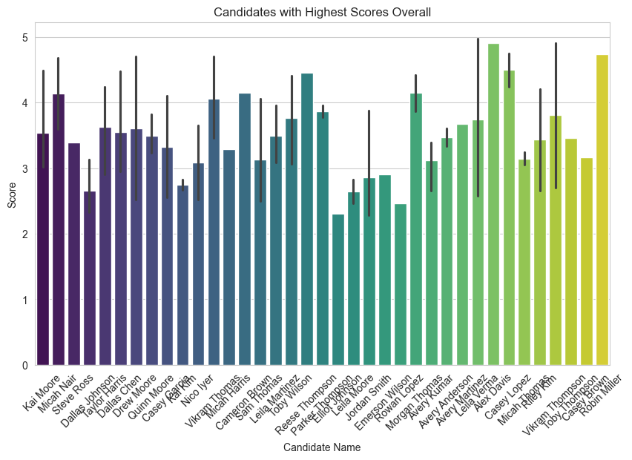

5.4 Plot 4:Bar chart to find panel members who conducted at least 3 interviews
# Run query#4 to find panel members who conducted at least 3 interviews
query4 = """
WITH avg_score_per_recruiter AS (
SELECT
sa.recruiter_id,
r.name AS recruiter_name,
AVG(e.score) AS avg_score
FROM sourcing_activity sa
JOIN evaluation e ON sa.candidate_id = e.candidate_id
JOIN recruiter r ON sa.recruiter_id = r.id
GROUP BY sa.recruiter_id, r.name
)
SELECT recruiter_id, recruiter_name, avg_score
FROM avg_score_per_recruiter
WHERE avg_score > 3.4;
"""
df4=pd.read_sql(query4, con=db_connection)
df4.head(3)

The output is:
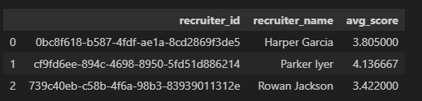
The plot generated is:
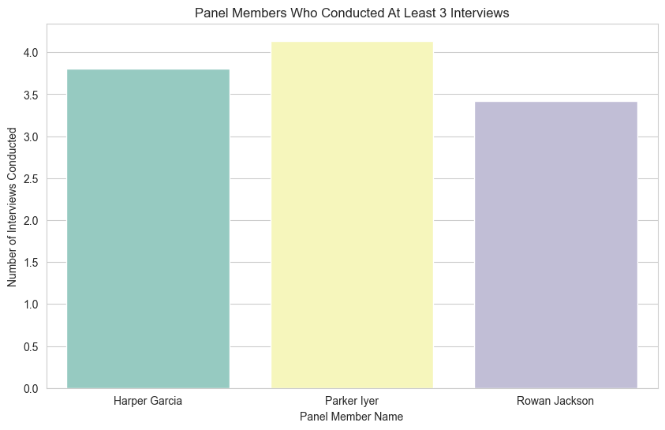

5.5 Plot 5: Histogram of Evaluation scores

# Query 5 Histogram of Evaluation Scores
score_df = pd.read_sql("SELECT score FROM evaluation", db_connection)
score_df.hist(bins=10)
plt.title("Distribution of Evaluation Scores")
plt.show()

The plot generated is:
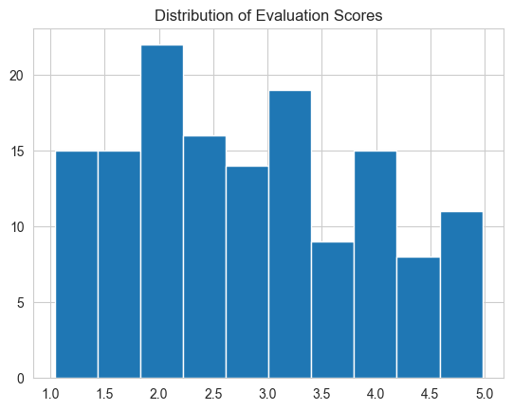

5.6 Plot 6:Pie chart of Offer Status
# Plot 6 – Pie Chart of Offer Status
offer_df = pd.read_sql("SELECT status, COUNT(*) AS total FROM offer GROUP BY status", db_connection)
offer_df.plot(kind='pie', y='total', labels=offer_df['status'], autopct='%1.1f%%')
plt.title("Offer Status Distribution")
plt.ylabel("")
plt.show()

The plot rendered for the query is:
